6.1 Choose a storage mode
The storage mode (or connection mode) for Power BI semantic models
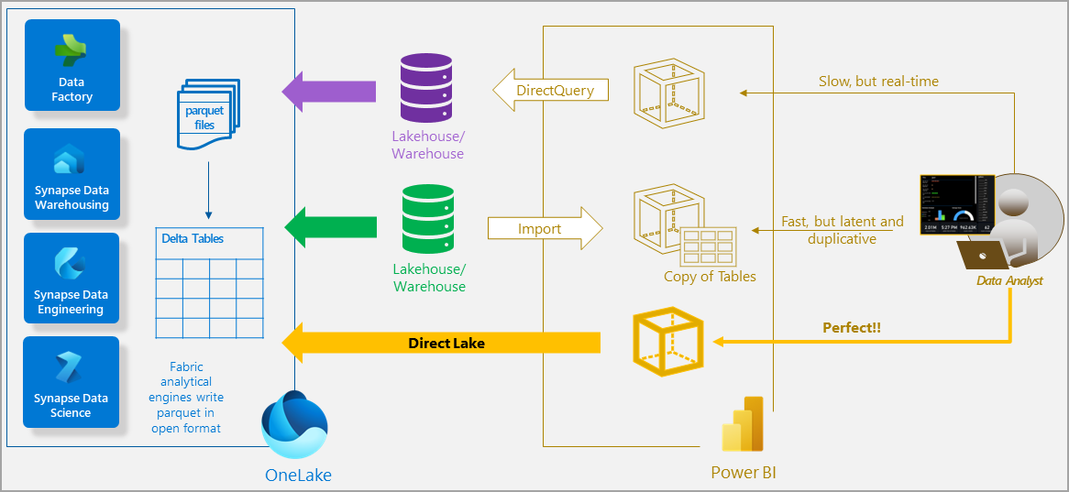

Import mode
You might want to choose IMPORT MODE when…
- Your data size is small enough to fit in memory

- You prioritise read performance

- You have no requirement for near real-time updates

- You want to use Calculated Columns/ Tables

- You want to combine data from multiple data sources

Direct Lake mode
You might want to choose DIRECT LAKE MODE when…
- You need near real-time updates

- Your data is stored in one Fabric data store

- Your dataset size is large (tens or hundreds of GB)

- You have data modelling capability ‘upstream’, in a Lakehouse or Data Warehouse

Direct Query mode
Choose DIRECT QUERY mode when…
- You need near real-time updates

- You can do data transformation ‘upstream’

- Building a composite model

- Your data lives in a data source compatible with Direct Query

